# Intradiem: Off-phone Activities

How the Intradiem Desktop Off-Phone Activities Feature Works

Your Responsibilities

What to Expect – Session Delivery

What to Expect – Task Based Sessions

What to Expect – Other Prompts

What to Expect – Tasks & Assignments

 Frequently Asked Questions

Related Documents

**Description:** Overview of what to expect when receiving and navigating off-phone activities through the Intradiem Desktop.

|  |
| --- |
| How the Intradiem Desktop Off-Phone Activities Feature Works |

 Wait for Intradiem to send an offer for these Tasks & Assignments. Waiting for the offer helps to ensure proper tracking for completion of Tasks & Assignments.

Through the following functions, the Intradiem Desktop provides you with greater opportunities to perform other work activities, enhance performance, and enjoy more variety in your daily workload:

* Intradiem monitors metrics, agent schedules and assignment priorities.
* When Intradiem identifies time on agent schedules, it delivers tasks and assignments directly to agents.
* Agents start and complete assignments from the Intradiem Desktop.

Top of the Document

|  |
| --- |
| Your Responsibilities |

1. Remain logged into the Intradiem Desktop.

**Note:** This allows you to receive alerts, messages, schedule offers and assignments.

1. Take calls as usual and await assignment sessions.

**Notes:**

* If you are on a call when receive an assignment session prompt, finish the call before starting the session.
* Change your phone state as appropriate before clicking the prompt’s **Start** button to begin the session.
* Do not multi-task during sessions.
* Do not use other desktop applications or browse the web.
* Do not step away from your desk.
* Stay focused and engaged in the assignment during your session, and finish the assignment delivered unless directed otherwise.

1. Stay in the session until you receive an End or Interrupt prompt.

* If you complete your session, click **End Session** and return to your next scheduled activity.

1. When you receive an End or Interrupt prompt:

* Exit your session closing any applications or documents associated with the session.
* Change your phone state as appropriate and resume taking calls.

1. When you finish an assignment, click the **Done** button.

* Click **Done** at the end of the assignment for it to be considered complete.

**Note:** If you leave the assignment screen before clicking the **Done** button, a Confirm Completion prompt displays. Click **Yes** or **No** to confirm completion of the assignment.

Top of the Document

|  |
| --- |
| What to Expect – Session Delivery |

Assigned tasks and activities will be delivered to agent computers via session prompts. When you click **Start** on a session prompt, the assignment window Opens.

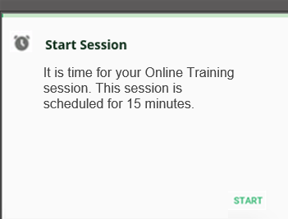

**Note:** Your NICE Schedule will not reflect the activity until after it is completed. When you receive a Start Session prompt, finish with your member and change your state as appropriate prior to clicking **Start** to open the assignment.

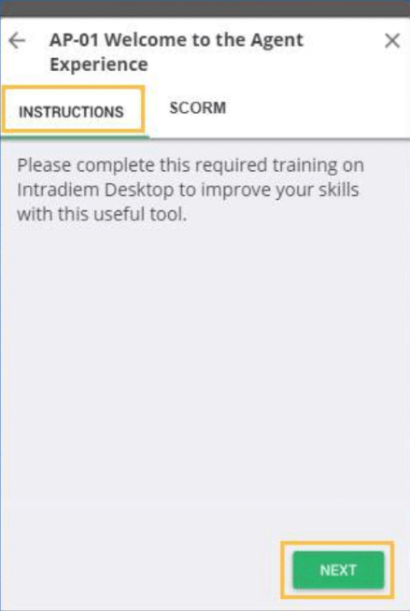

**Notes:**

* The instructions displayed explain what needs to be done.
* For multiple tabs, click the **Next** button or **Tab** key to continue.
* Activities that only deliver time will not include multiple tabs. Follow the instructions to complete the activity. (**Examples:** Call customers, read emails, etc.)

Top of the Document

|  |
| --- |
| What to Expect – Task Based Sessions |

Sessions that are task-based include multiple tabs on the assignment window. Depending on the nature of the tabs shown, you can access an attachment, hyperlink or training.

**Example:** The SCORM tab representing an online training assignment, which can be opened by clicking **Start.**

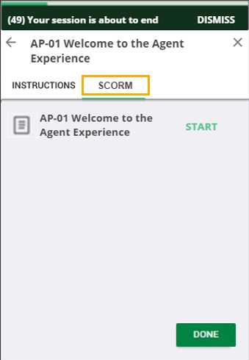

**Note:** Assignments may include tabs for files or links.

Each assignment window contains several key features:

1. **Progress bar:** It is a green bar at the top of the window which tracks your progress.
2. **Session Warning:** If enabled, this warning message displays with “x” minutes prior to the duration end.
3. **DONE button:** Icon - Important Click the **DONE** button at bottom right when the assignment is complete and return to your next scheduled activity.

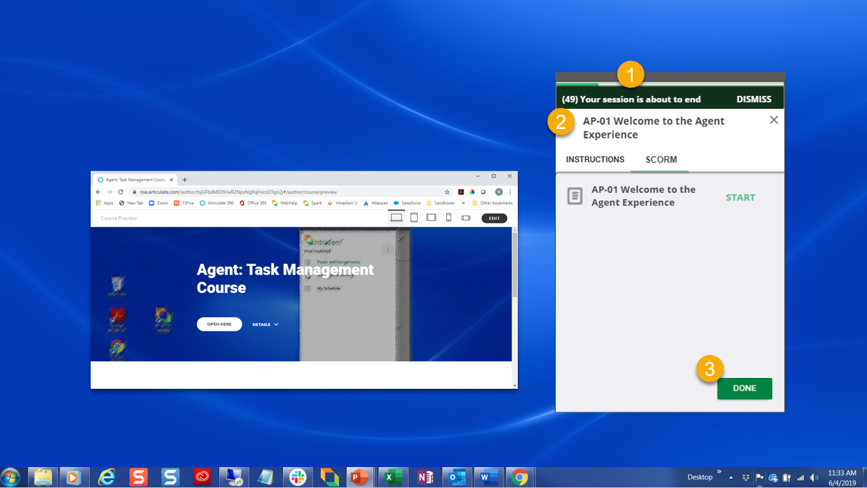

Top of the Document

|  |
| --- |
| What to Expect – Other Prompts |

Additional examples of session prompts you may see during a task-based session are shown below.

* A Session Over prompt displays if a session is not concluded by clicking the **Done** button.

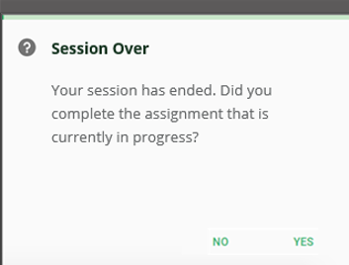

**Note:** Clicking **Yes** will mark the assignment as complete. Clicking **No** will mark the assignment as incomplete and the system will try to redeliver it .

* A Session Interrupt prompt indicates that customer volume requires agents back on the phone.

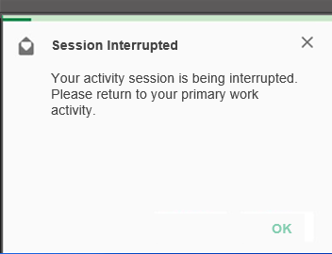

**Note:** When a Session Interrupt prompt displays, close any open windows and files then change your state as appropriate and return to taking calls. The assignment is redelivered when conditions improve.

Top of the Document

|  |
| --- |
| What to Expect – Tasks & Assignments |

The Tasks & Assignments feature includes two sections that track your open and completed assignments. It can be accessed by clicking the “Tasks & Assignments” option from the main menu.

The “To Do” tab displays a list of your open assignments, which can be accessed by clicking on them.

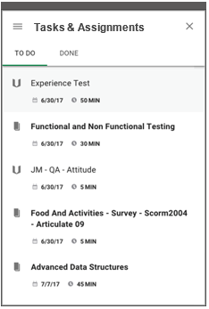

The Done tab displays completed assignments, which may be reopened for review. Training scores (within Intradiem) can be tracked from this screen.

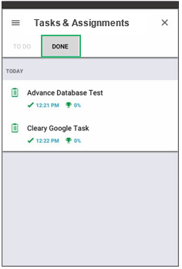

The Icon legend provides examples of and demonstrates the meaning of various icons you may see within the Tasks & Assignments feature.

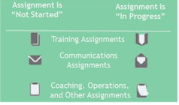

Top of the Document

|  |
| --- |
| Frequently Asked Questions |

Refer to as needed:

|  |  |  |
| --- | --- | --- |
| **#** | **Question** | **Answer** |
| **1** | Why doesn’t NICE reflect these in my schedule when the Session, Task or Assignment is offered by Intradiem? | Intradiem uses business conditions and scheduling information to determine the best timeframe to send these offers. These are ever changing and not prescheduled.  Once the business and schedule conditions are aligned, Intradiem will send these offers.  Upon acceptance of the offer or when started, Intradiem updates the schedule in NICE after completion of the Session, Task or Assignment. |
| **2** | Why can’t I multi-task during a session? | The time in your training session is monitored and is automatically reported to NICE. Multi-tasking will cause discrepancies in adherence. |
| **3** | Do I need to track and report the amount of time I spend in a session? | No. Your time in is automatically tracked and transmitted to NICE. |
| **4** | What happens if I am unable to complete the course during the session? | Do your best to complete the assignment within the allotted time, as completions and the number of sessions and amount of time taken to complete each assignment is automatically tracked and reported. If you do not complete the course during your session, the system redelivers the assignment to you when conditions allow. |
| **5** | What happens if I receive an “Interrupt” prompt? | Once you click OK on the “Interrupt” prompt, you will be placed in “available” status and receive a call (since you are being interrupted because a call is holding).  The order in which you click OK or close the assignment, will not affect your session end time.  Your session will end when the “Interrupt” prompt is presented. Close your assignment to ensure the system does not continue calculating “time in assignment.” |
| **6** | Can I review my previously completed assignments? | Yes, you can access, and review previously completed assignments from the Done tab in the "Tasks & Assignments" section. Click on any of the assignments to view the results, included courses, and attachments (**Examples:** URLs, PDFs, etc.). |
| **7** | What should I do when I get an Intradiem offer? | When you get an offer for Training, ABA, or Coaching, you should accept the offer after you finish your call, not during.   * If the offer goes away on its own, it will not count negatively towards your score. * If you're not on a call, offers not accepted after 2 minutes will negatively impact your Intradiem Accept Rate and are classified as an Ignored offer. * If you Decline the offer, this will also negatively affect your Intradiem Accept Rate. |
| **8** | Which offers affect my Accept Rate? | Training, ABA, and Coaching offers affect your Accept Rate if declined when not on a call.  Offers for early lunch, break, early leave or thrive that are declined do not affect your Accept Rate. These offers are optional. |

Top of the Document

|  |
| --- |
| Related Documents |

[Customer Care Abbreviations, Definitions, and Terms (017428)](https://thesource.cvshealth.com/nuxeo/thesource/#!/view?docid=c1f1028b-e42c-4b4f-a4cf-cc0b42c91606)

Top of the Document

Not to Be Reproduced or Disclosed to Others Without Prior Written Approval

**ELECTRONIC DATA = OFFICIAL VERSION / PAPER COPY = INFORMATIONAL ONLY**